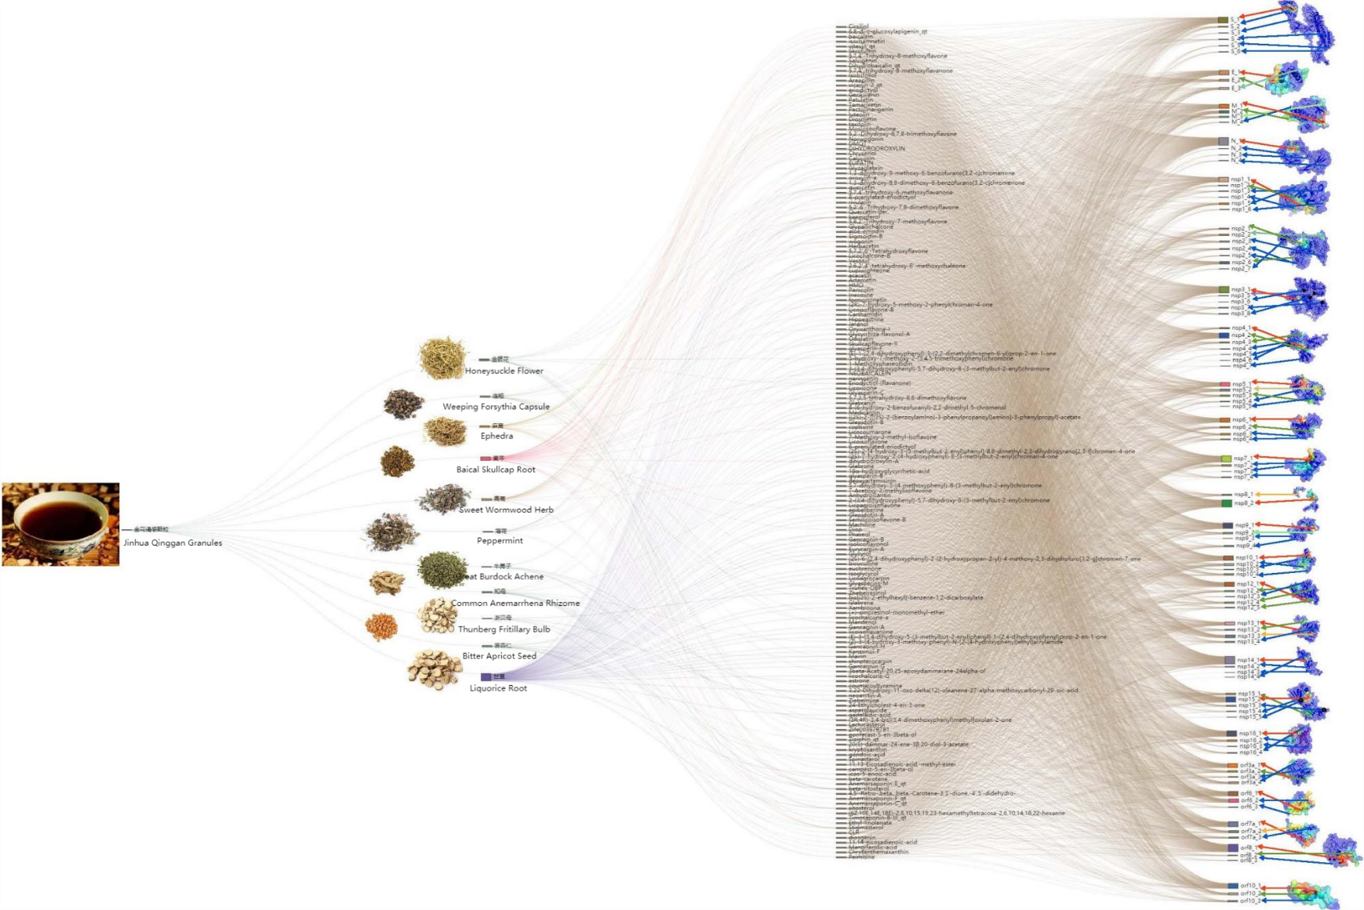

Fig. S1 **Herbs-Compounds-Proteins** docking result for the herbs prescription of Jinhua-Qinggan

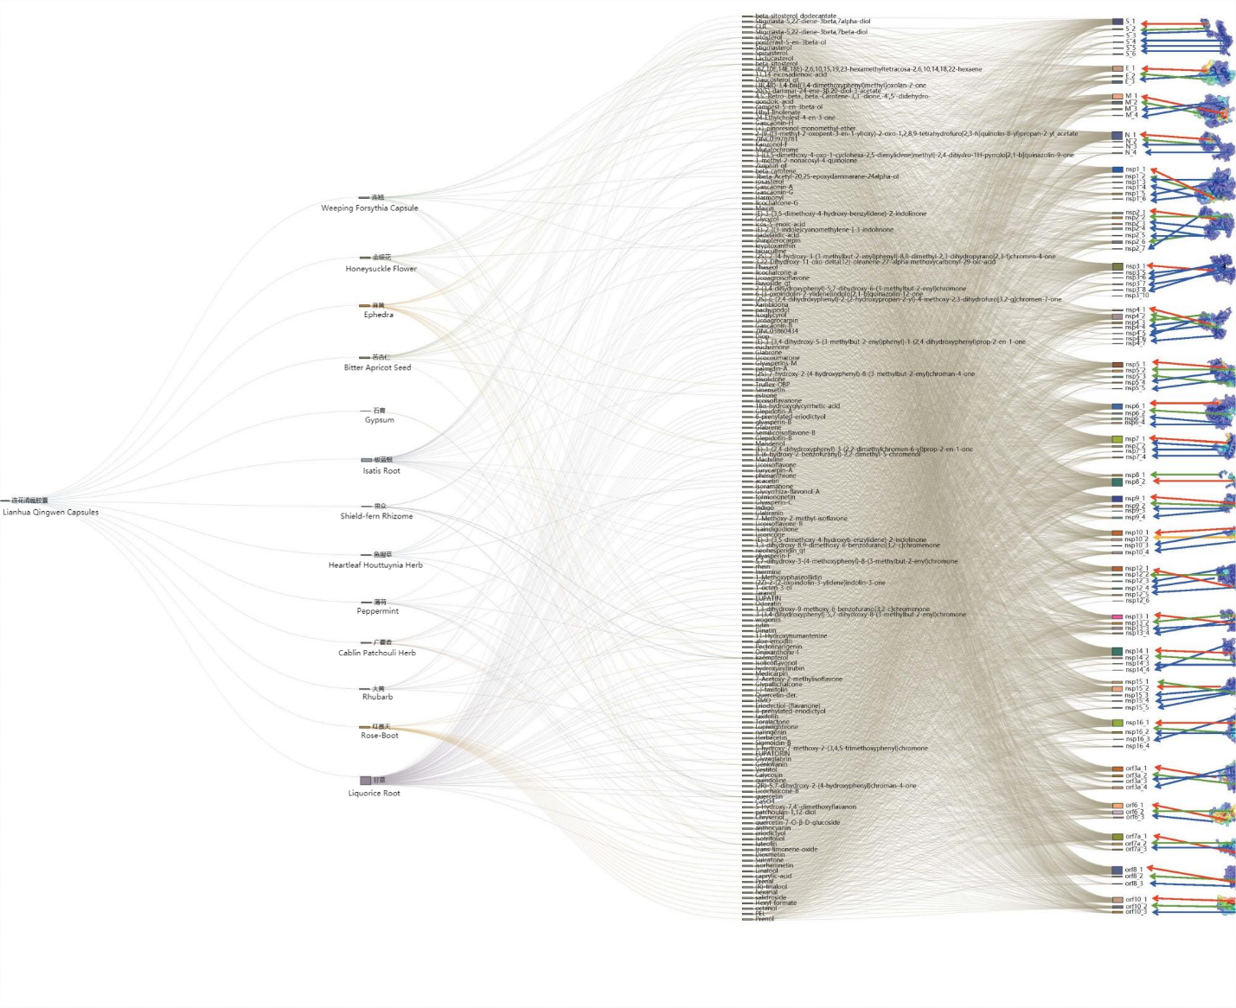

Fig. S2 **Herbs-Compounds-Proteins** docking result for the herbs prescription of Lianhua-Qingwen.

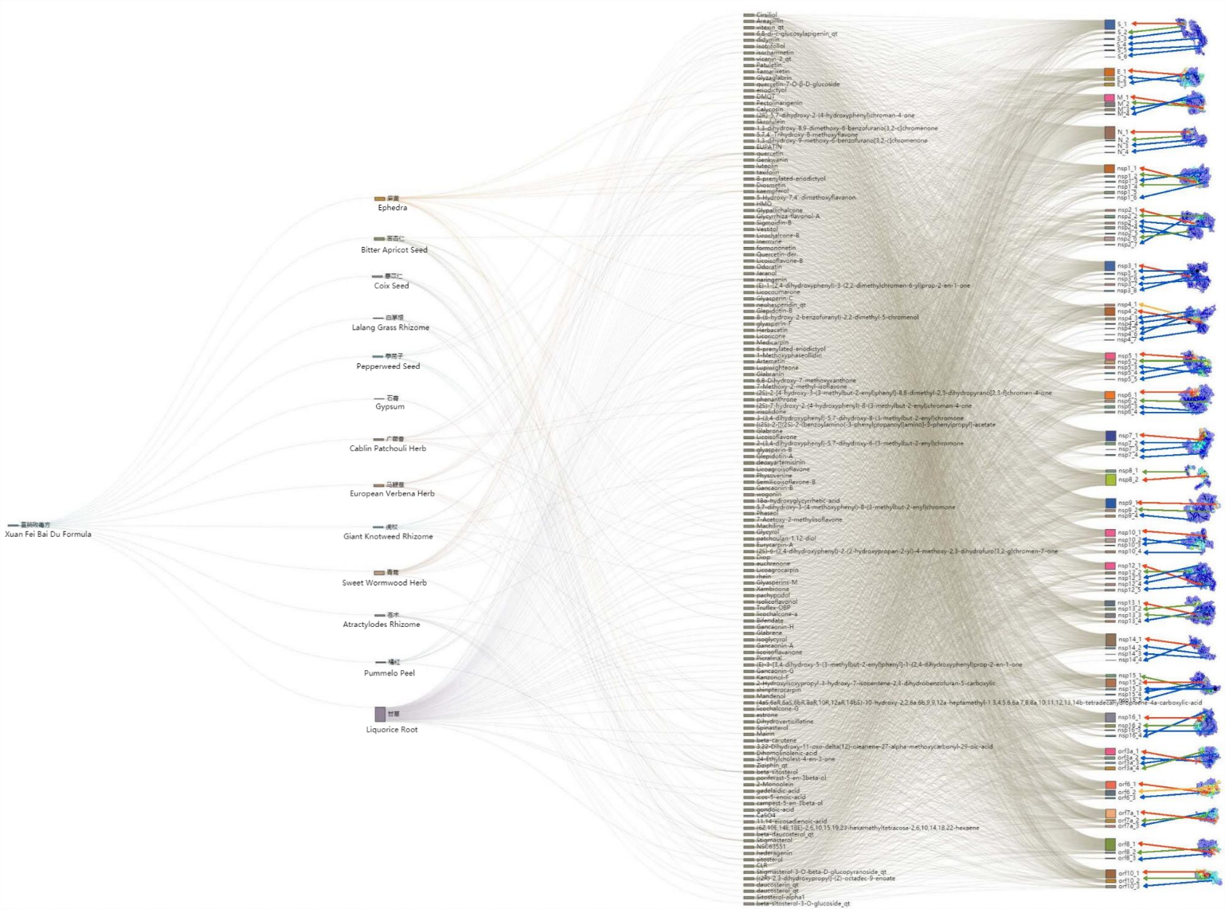

Fig. S3 **Herbs-Compounds-Proteins** docking result for the herbs prescription of Xuanfei-Baidu..

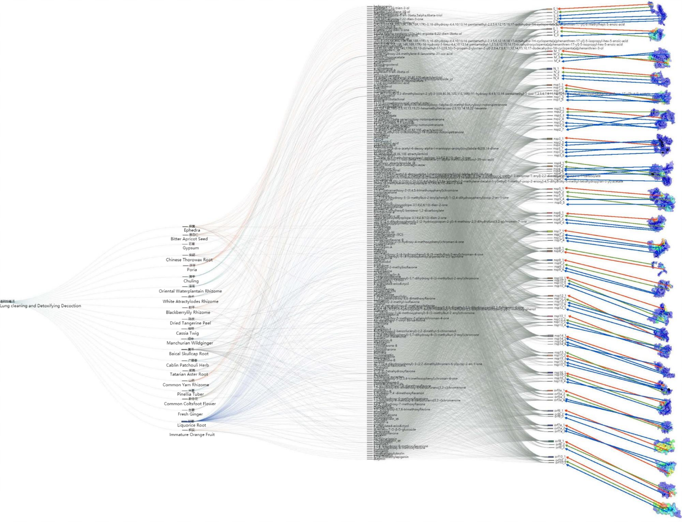

Fig. S4 **Herbs-Compounds-Proteins** docking result for the herbs prescription of Qingfei-Paidu.

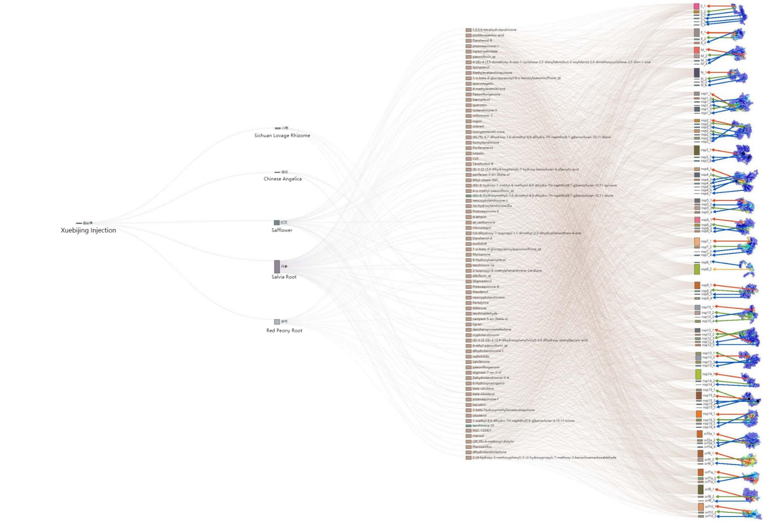

Fig. 5 S**Herbs-Compounds-Proteins** docking result for the herbs prescription of Xuebijing.

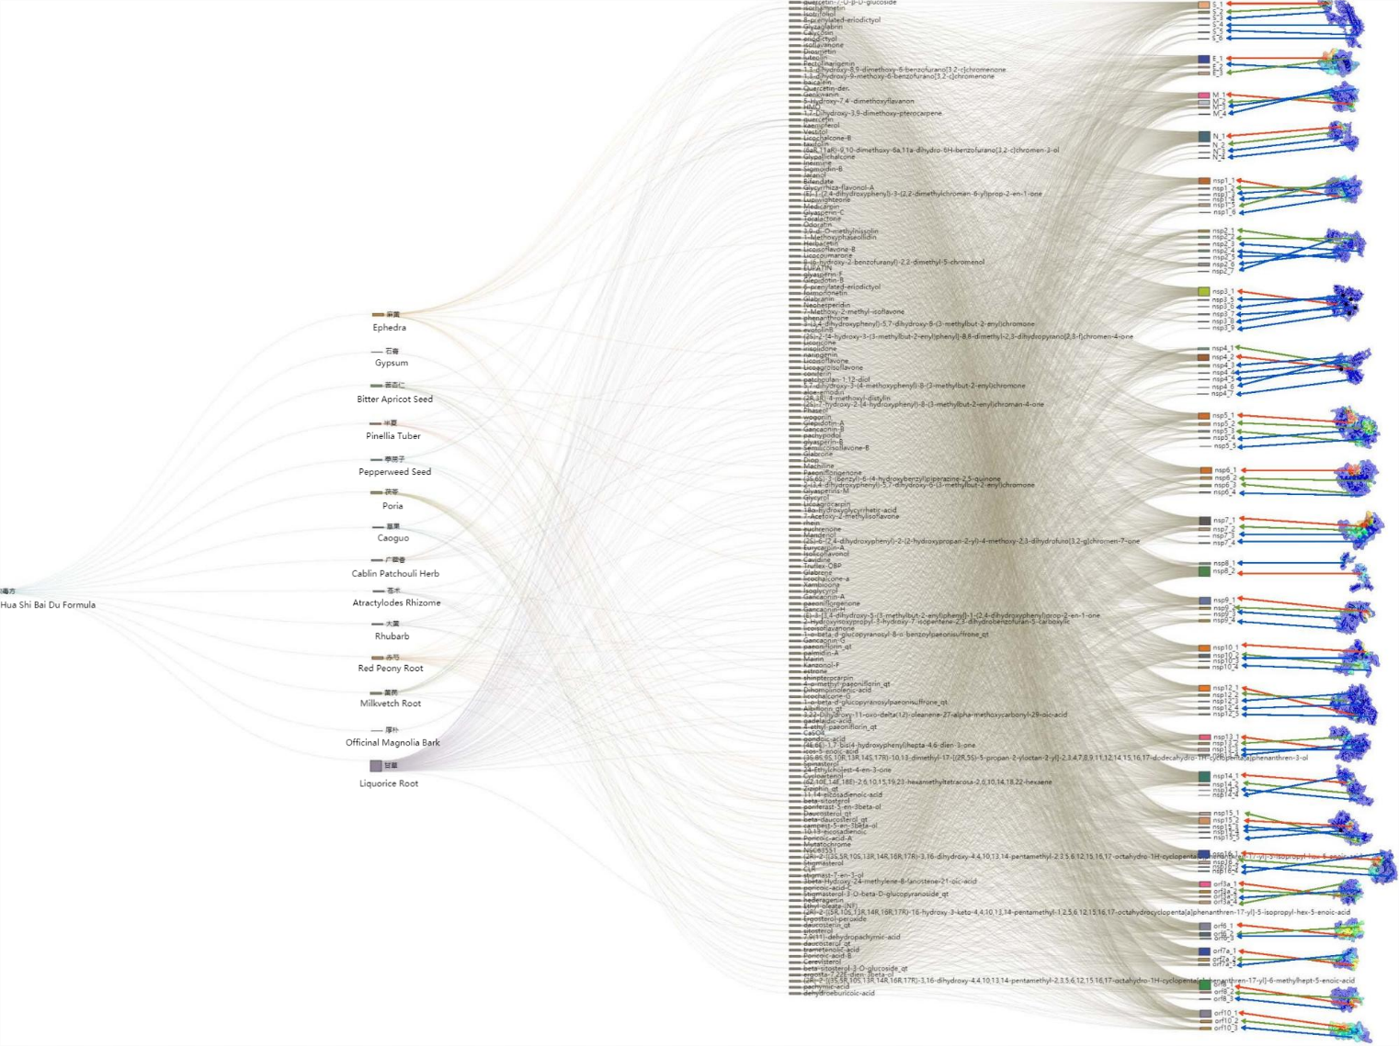

Fig. S6 **Herbs-Compounds-Proteins** docking result for the herbs prescription of Huashi-Baidu.